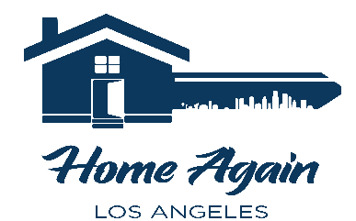

Homeless Services Waiver

By signing this waiver, you are ELIGBLE to use both programs. You are NOT REQUIRED to use both.

Shower & Laundry Program:

- This agreement waives all claims against Home Again Los Angeles. Your signature is binding.
- I agree that Home Again Los Angeles (HALA) allows me to use the shower, washer, dryer, and related facilities at its building located at 1304 W. Burbank Blvd., Burbank, California.
- I agree to assume any risk of injury, whether mental or physical, and any damage or loss of any kind arising directly or indirectly from my use of the facilities described above, or from hygiene and laundry products supplied to me, or from my presence at HALA.
- I release HALA, its staff, volunteers, donor supporters, its Board of Directors, and each individual member thereof from all claims, allegations, actions, lawsuits, damages, and judgements that might arise from HALA allowing my use of the facilities. Regardless of the circumstances, HALA shall be held harmless.
- No one from HALA has made any representations or promises to me about the facilities, express or implied.
- I acknowledge showering can be hazardous. I alone am responsible for my personal safety, as well as for the care of my personal property. I declare that I am in sufficiently good health to engage in showering and laundry activities on my own and wish to do so without assistance or oversight. I am not under the influence of alcohol or any drug that may impair me physically or mentally to any extent whatsoever.
- I understand that I must abide by HALA’s Shower and Laundry Guidelines.
  - Showers are scheduled in 20-minute intervals
  - Toiletries like soap and shampoo are available in the showers and at the front desk.
  - There is no toilet in the shower area. Use the toilet before entering the shower area.
  - Do not leave the shower area unless fully dressed.
  - Used towels must be left in the designated area.
  - Loitering, eating, and smoking in the shower area is not permitted.
  - Shower area must be cleaned, including water pools, before leaving the shower area.
  - DO NOT wash clothing in the shower.
  - If you are more than 5 minutes late for your appointment, your time may be given to another client.
  - If you miss a shower without calling to cancel IN ADVANCE, you shower privileges may be revoked.
  - No one who appears to be under the influence of alcohol or drugs will be permitted to use the shower.
  - HALA reserves the right to refuse use of the shower facilities at the staff’s discretion.
  - Clients MUST remain in the laundry room with their belongings and may not come and go.

Client Name (Print): _______________________________________________________________________

Client Signature: _________________________________________________________________________

Client Date of Birth: _______________________________________________________________________

Today’s Date: ____________________________________________________________________________

